2016

LADBS
User Manual for Building Information Online

12-Feb-16

Contents
1 Introduction 3
2 Search by 3
2.1 Search by – Address 4
2.1.1 Partial Search Pop-up 5
2.2 Search by – Intersection 5
2.3 Search by – APN 7
2.4 Search by – PIN 9
2.5 Search by – Legal 10
2.6 Search by – Building 11
3 Map Views 11
3.1 Map Views – Legends 12
4 Tools 13
4.1 Tools – Measurement 13
4.2 Tools – Google Street View 13
4.3 Tools – Zoom 14
4.4 Tools – Page Refresh 14
5 Links 14
6 Permit and C of O Information Page 14

1 Introduction

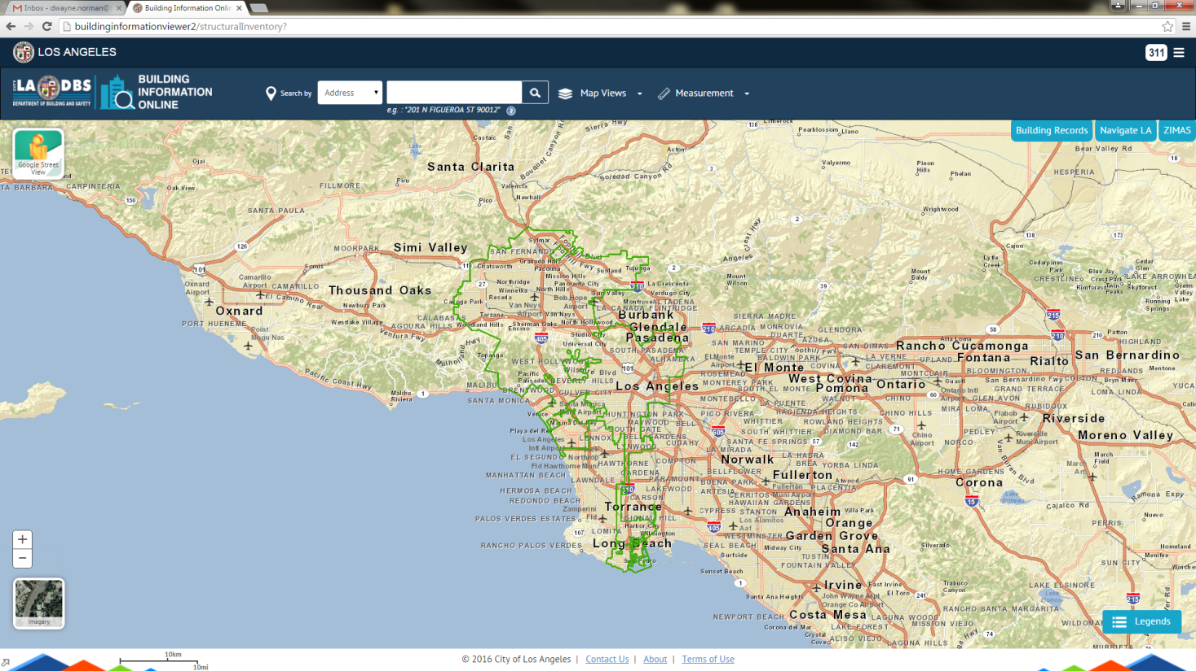

The Building Information Viewer is an online mapping application created and maintained by the City of Los Angeles’ Department of Building and Safety. The application’s intent is to provide ease in obtaining information about buildings and parcels within the City of Los Angeles. The viewer hosts numerous functionalities which aid in the exploration of the rich data set provided by the Department of Building and Safety.

2 Search by
In this application, locating any property within the City of Los Angeles can be done using either of the following options:

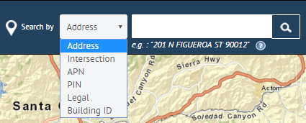

• Address
• Intersection
• APN
• PIN
• Legal
• Building ID

2.1 Search by – Address
Searching by address is done by selecting the address option from the dropdown menu, then entering an address in the adjacent search box. While entering an address, a list of suggested addresses will appear beneath the search box. Select from the suggested list or complete your typing of the address.

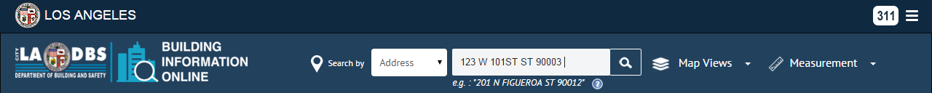

- If a match is found, the map will zoom to the corresponding parcel. Both the address point and parcel will be highlighted, while a corresponding parcel summary box appears on the right side of the screen.

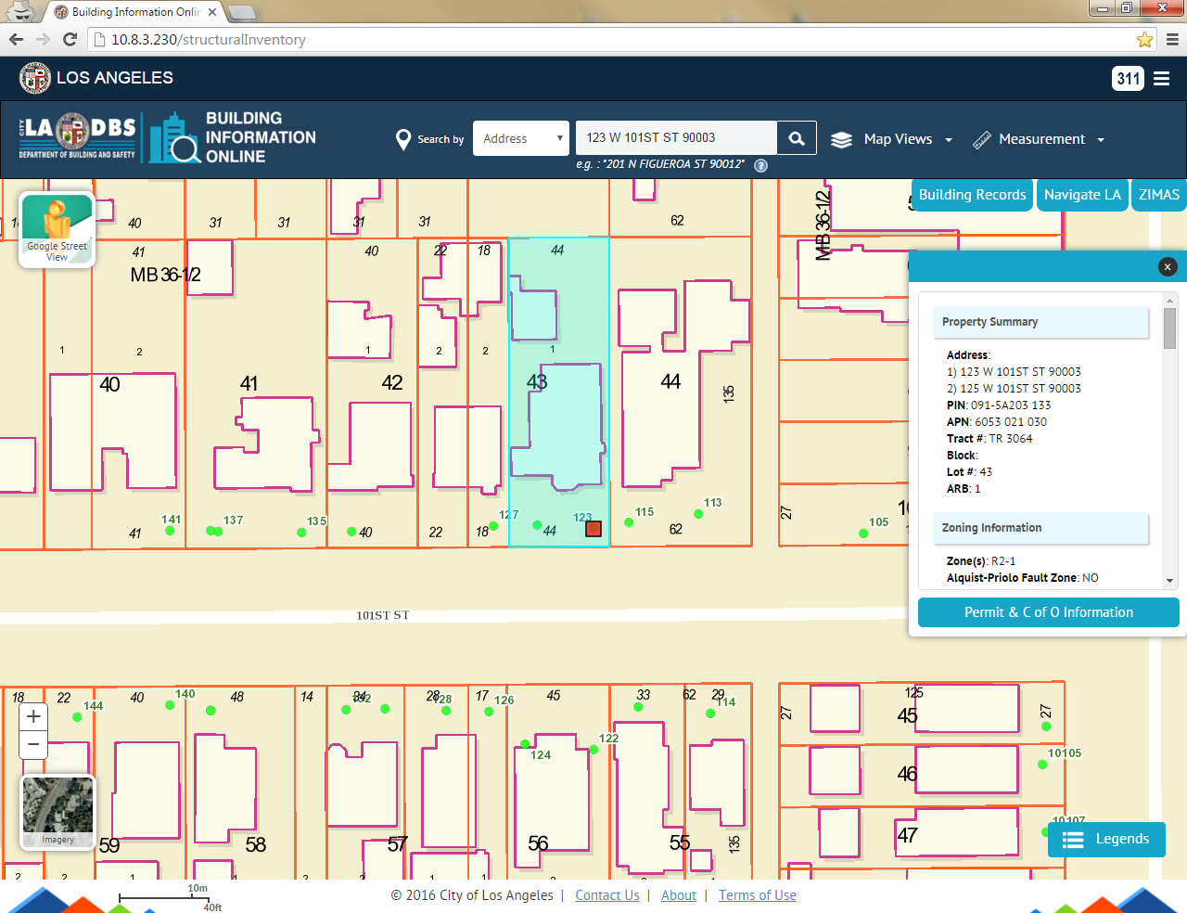

2.1.1 Partial Search Pop-up
If an incomplete address is entered in the search box, then a pop-up of related search addresses will appear. Each address is selectable and will locate the clicked address on the map.

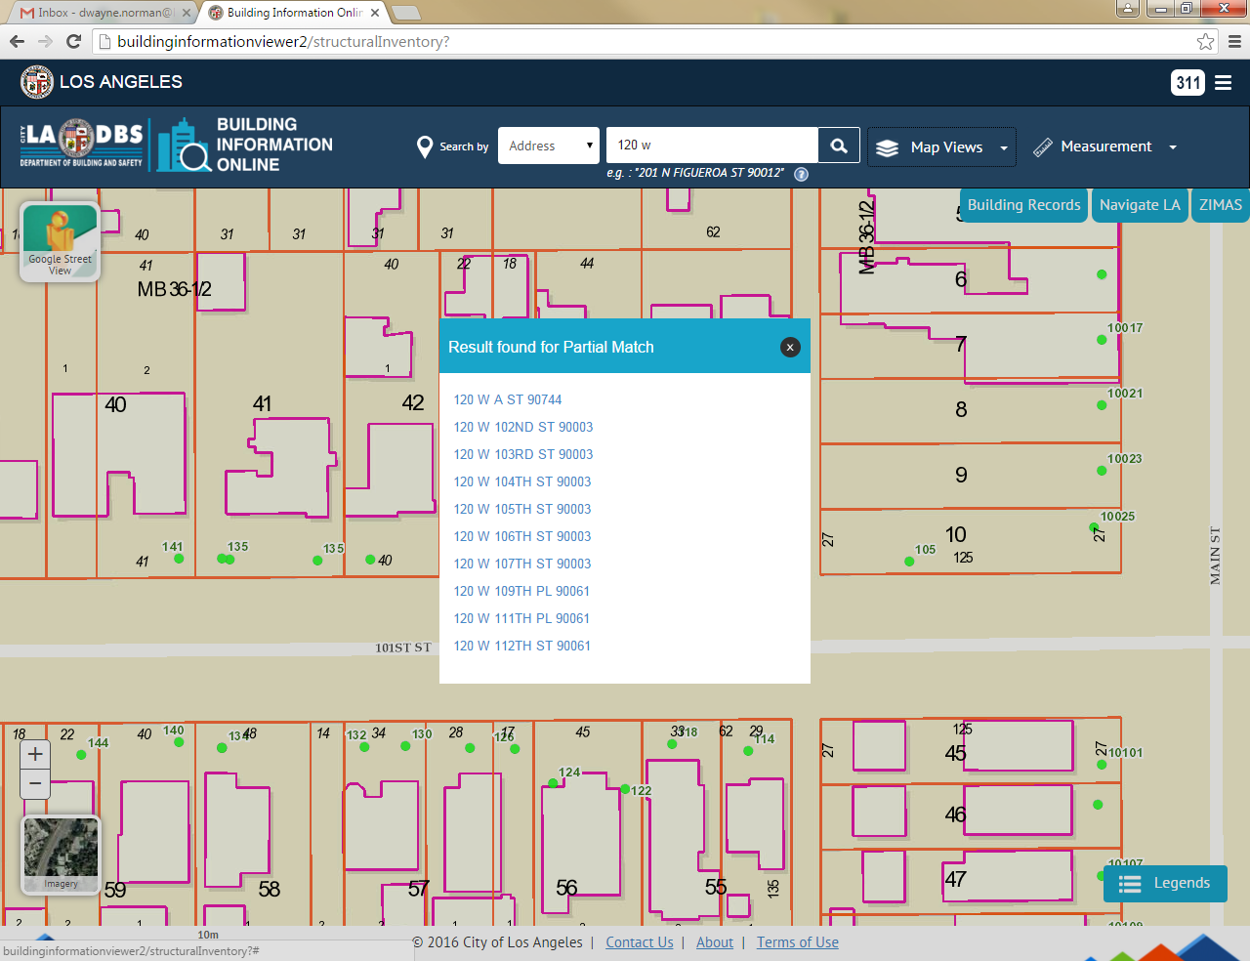

2.2 Search by – Intersection
Searching by a street intersection is done by selecting an intersection option from the search by drop down menu, then entering a street intersection in the adjacent box. Acceptable intersections entries are provided below:
- 120th & Figueroa
- 120th and Figueroa
- 120th @ Figueroa
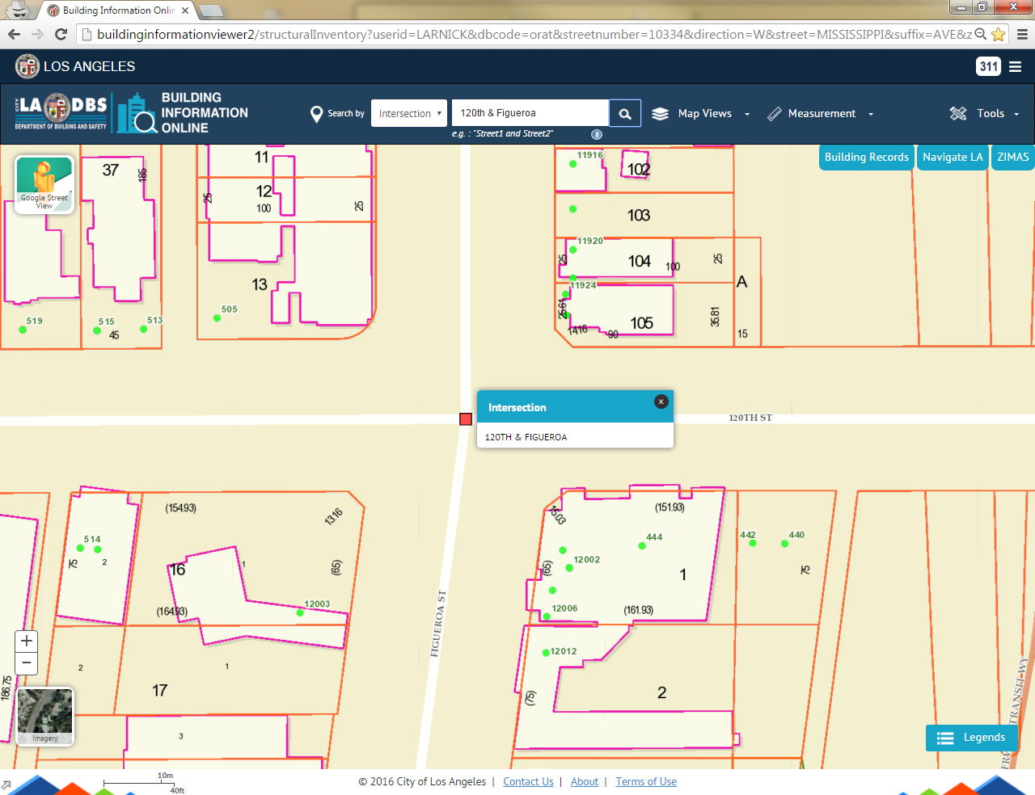

1. The map will be adjusted to the intersection location.
2. A pop up box showing the intersection searched will be displayed.

3. If the user enters two streets that do not intersect, a pop up box “Intersection couldn’t be found” will be displayed.

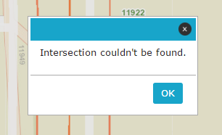

2.3 Search by – APN
Searching by APN (Assessor’s Parcel Number) is done by selecting the APN option from the search by dropdown menu. Enter the numeric APN # without dashes in the input field. E.g. APN - 6087017026
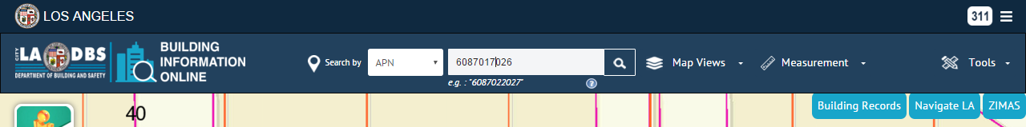

1. If a match is found, the map will zoom to the parcel (APN) and the parcel summary box will appear.
2. The parcel (APN) will be highlighted.
3. The APN may span one or multiple parcels (PIN). If so, other parcels sharing the same APN can be viewed by clicking the prev, number, or next buttons located at the bottom of the parcel summary popup box.

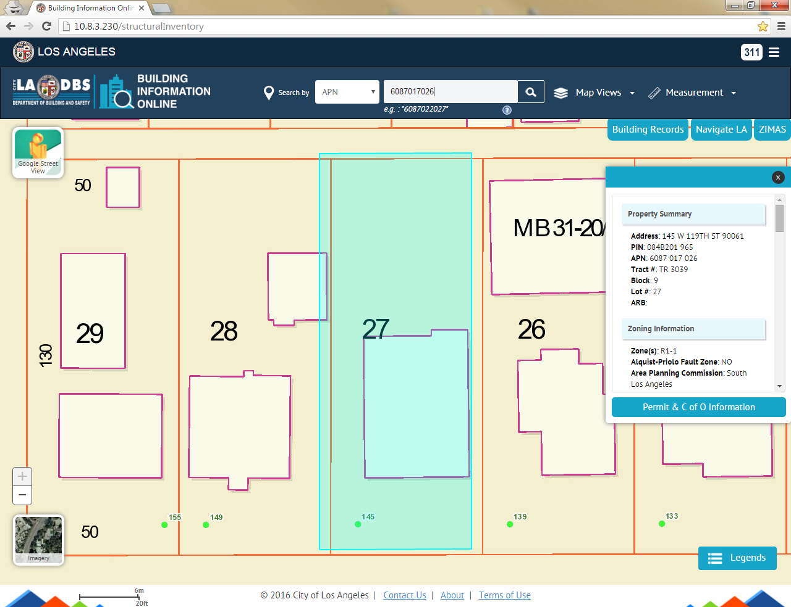

5. If an incorrect APN is entered, a pop up box displaying “APN couldn’t be found” will be displayed.

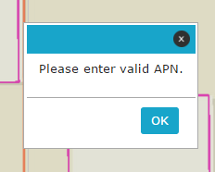

2.4 Search by – PIN
Searching by PIN is done by selecting the PIN option from the search by dropdown menu, the input text box will accept PIN as an input field. The PIN must be thirteen characters in length including spaces. Eg : PIN – 084B201 959
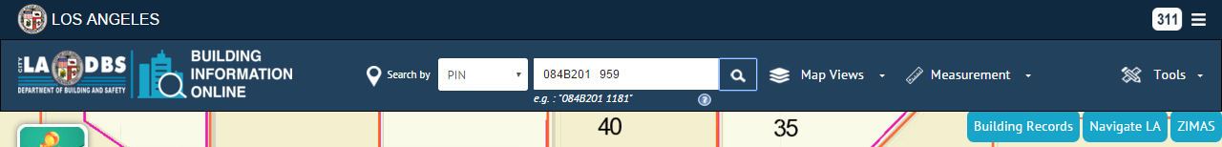

1. If a match is found, the map will zoom to the corresponding parcel.
2. The parcel is highlighted.
3. The corresponding parcel quick view is shown as a pop up box.
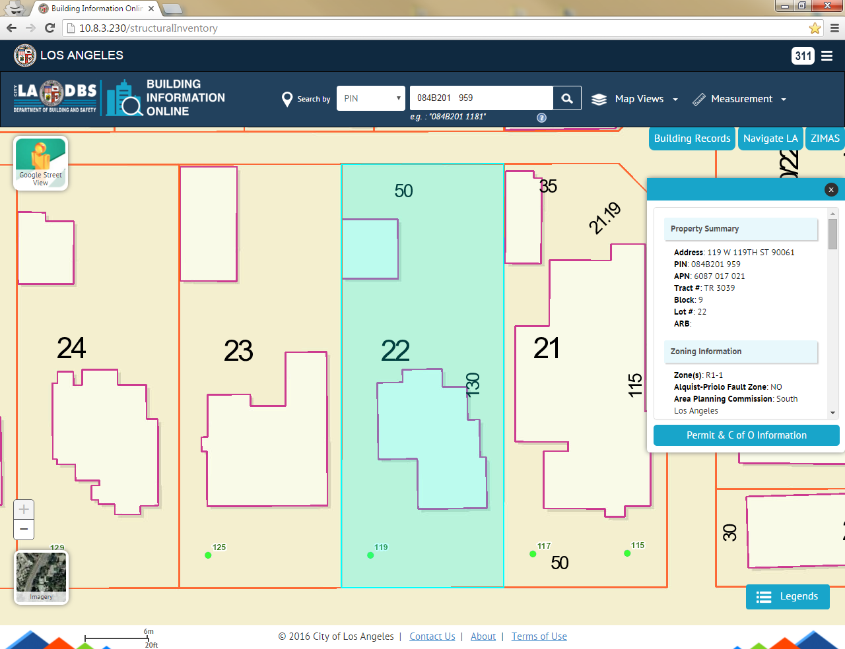

5. When entering an incorrect PIN, a pop up box displaying “PIN couldn’t be found” will be displayed.

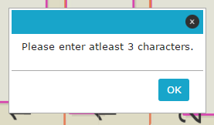

2.5 Search by – Legal
Searching by legal description is done by selecting the legal option from the search by dropdown menu.

The following fields are provided for the legal search:

➢ Tract
➢ Lot
➢ Block
➢ Arb

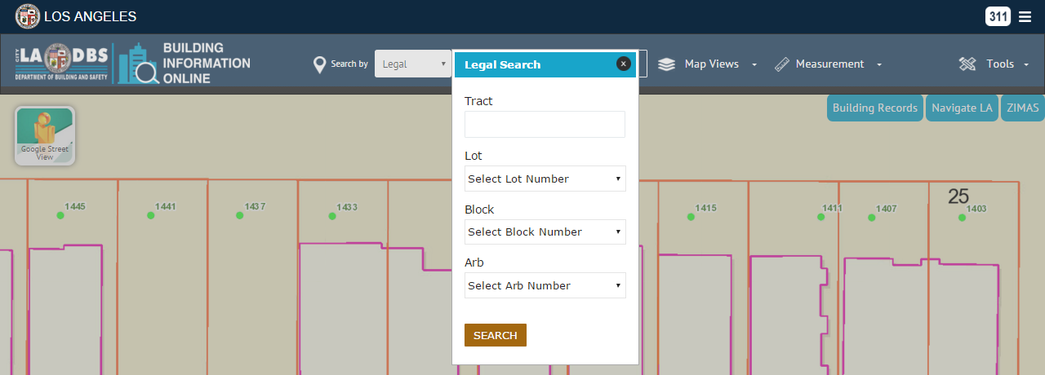

1. Tract and Lot are the required fields, while Block and Arb are optional.
2. The Tract field is populated in the drop down pick-list after the input of approximately 3-5 characters and spaces.
3. Each drop down menu in the legal search box becomes prepopulated once the previous field has been populated.
4. If a match is found, the map will be zoomed to the corresponding parcel.
5. The parcel will be highlighted and the corresponding parcel summary box will appear.

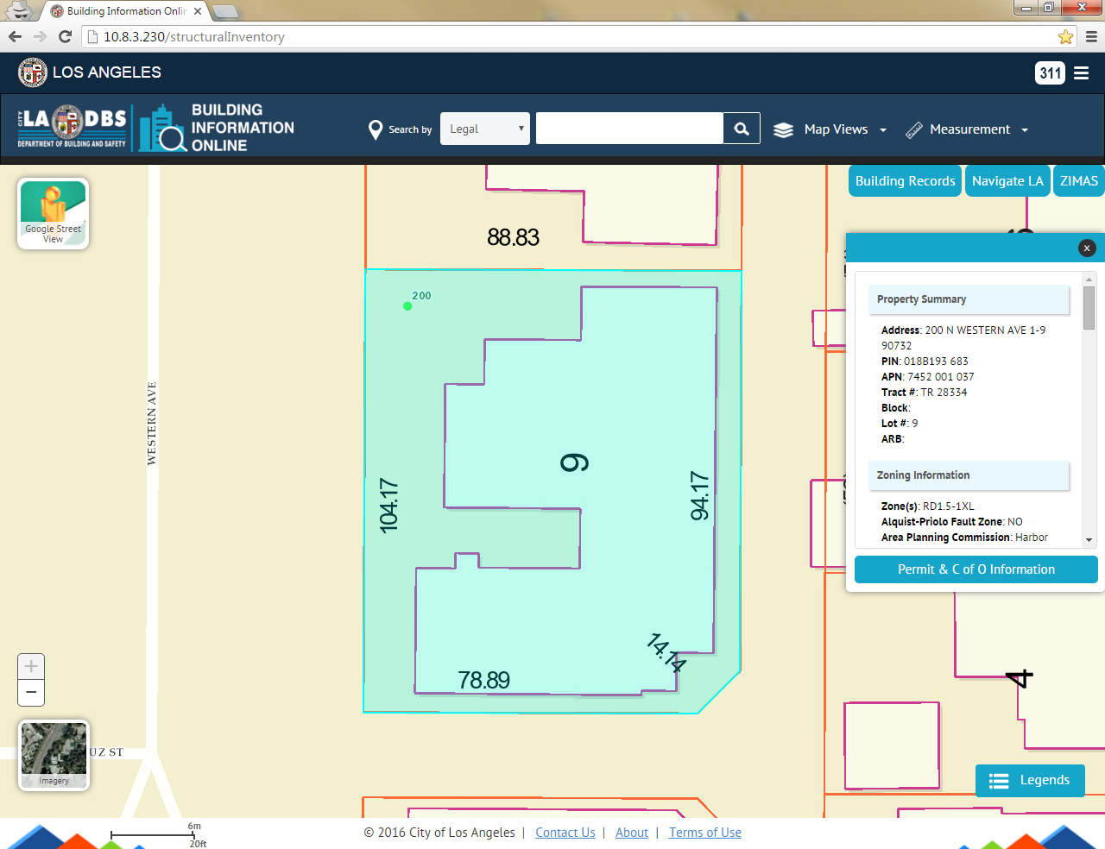

2.6 Search by – Building
Searching by Building ID is done by selecting the Building ID option from the search by dropdown menu, the input text box will accept Building ID as an input field. The Building ID must be twelve characters in length. Eg : Building ID – 478000794837
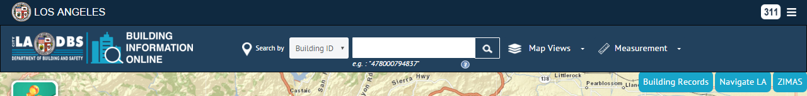

1. If a match is found, the map will zoom to the corresponding building.
2. The corresponding parcel quick view is shown as a pop up box.

3 Map Views

There are five Map Views within the Building Information Viewer. Each view activates a set of layers specific to the selected Map View. When a Map View has been selected, a halo will appear around the Map View icon and a green check mark will appear below the icon. The Building Information Viewer can be returned to the default view by clicking the Reset button or deactivating a Map View.
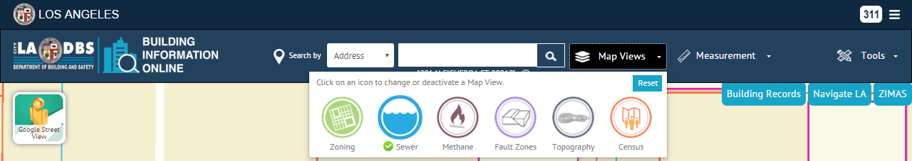

3.1 Map Views – Legends
The Legends tool displays all active layers respective of the activated Map View, and is located at the bottom right of the screen. Each layer is visible at specific extents.

Default View:
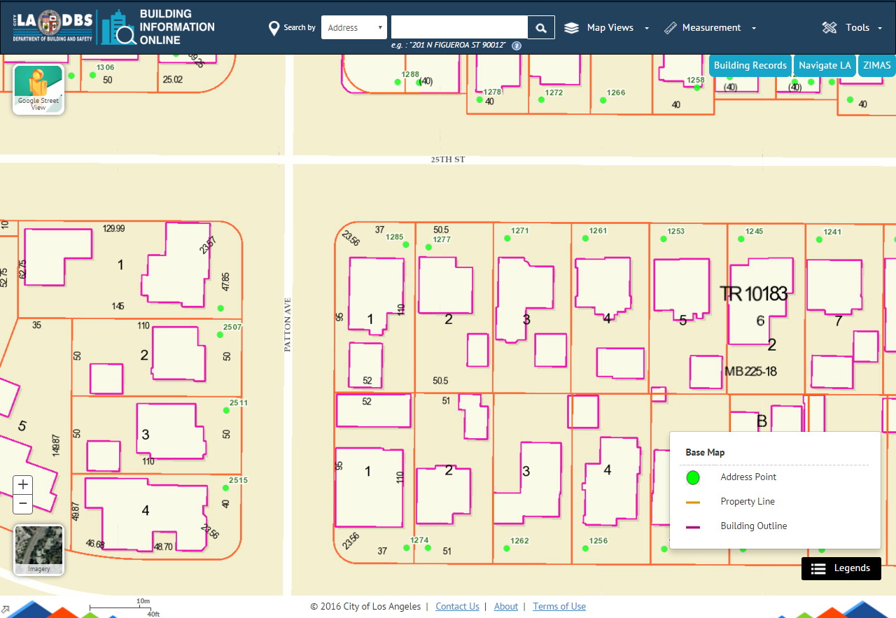

Methane Map View
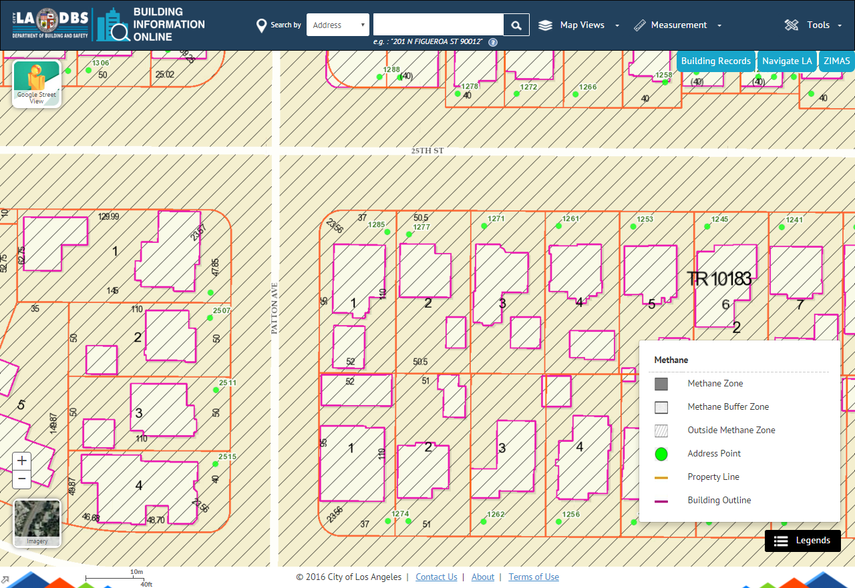

4 Tools
BIO hosts a suite of tools which allow either for measuring, 3D imagery, or navigating the map.

4.1 Tools – Measurement
The Measure tool allows for the measuring of distance, area calculation, and XY coordinates on the map.
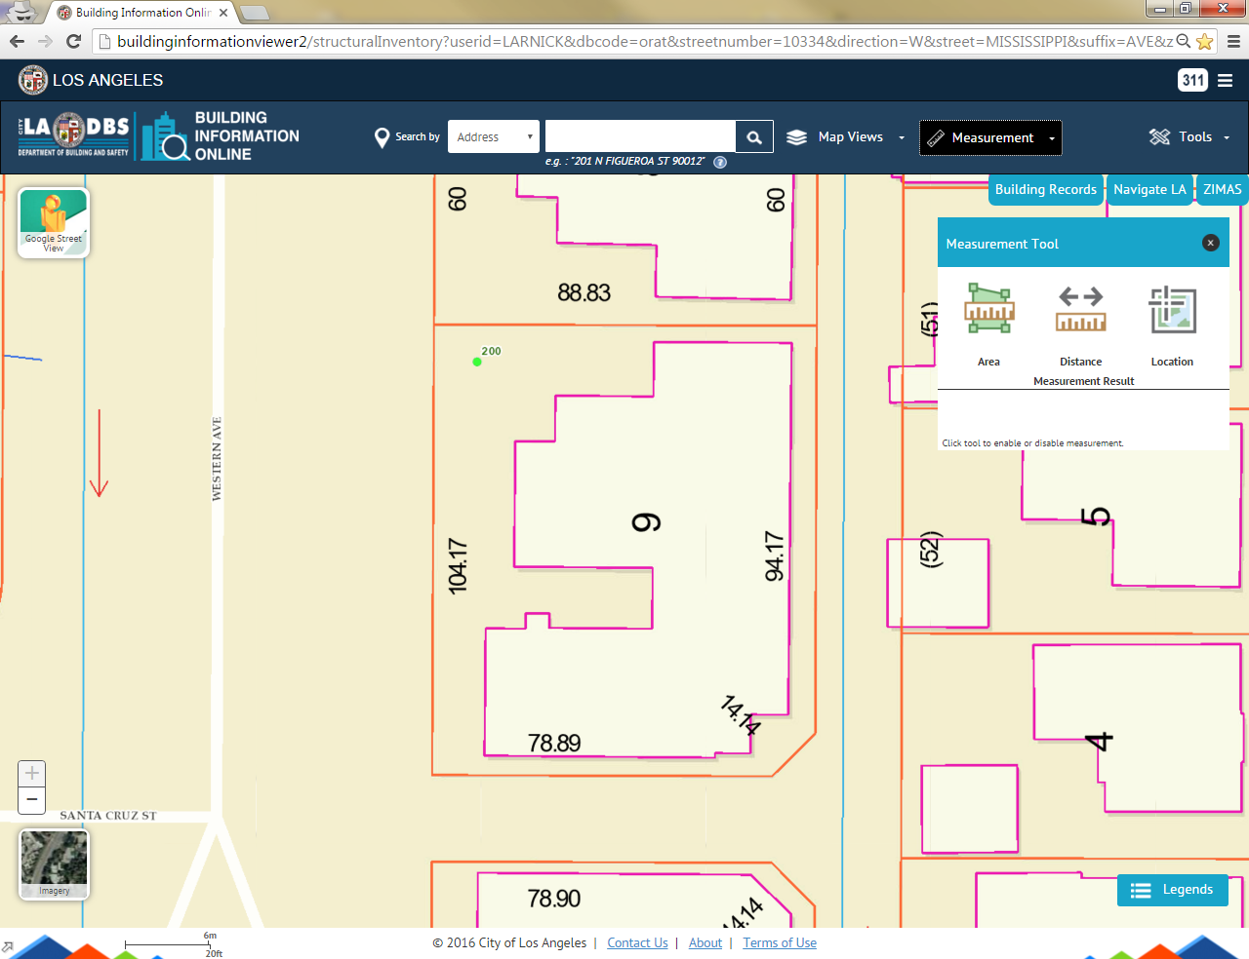

4.2 Tools – Google Street View
The Google Street View tool allows for a 3D view of properties within the City of Los Angeles. Clicking the Google Street View Icon will activate the tool.

After the tool is activated, click anywhere on the map to open the Google Street View window.

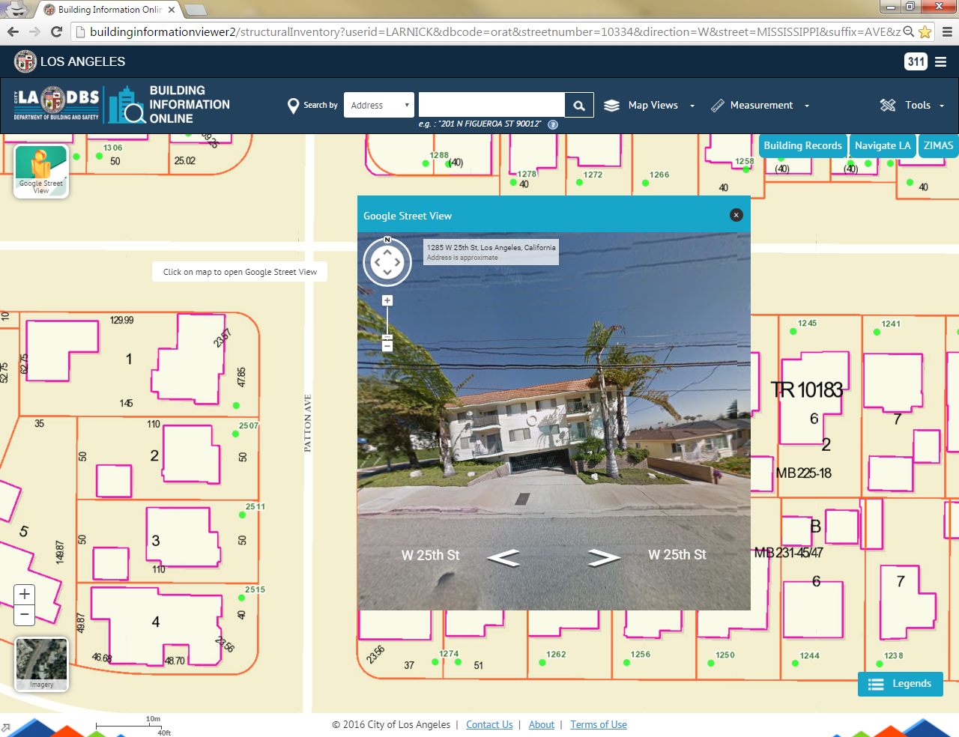

4.3 Tools – Zoom
The two zoom tools are located at the bottom left of the screen. These tools can be used to adjust how close are far the user wishes to view the map.
- The Plus sign adjusts the map to a closer extent.
- The Minus sign adjusts the map to a further extent.

4.4 Tools – Page Refresh
Clicking the Building Information Online icon located on the left side of the banner will refresh the map viewer.
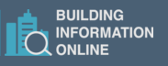

5 Links
External links are available as three tabs located near the top right corner of the banner. The available links are:
1. Building Record: Building and Safety’s online building records system.
2. Navigate LA: Bureau of Engineering map viewer.
3. ZIMAS: Planning department map viewer.
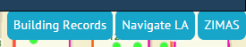

6 Permit and C of O Information Page
The Parcel Detail page contains permit information associated to the addresses and buildings which reside on the parcel. This page can be accessed by clicking the Permit and C of O Information button on the parcel summary popup box.
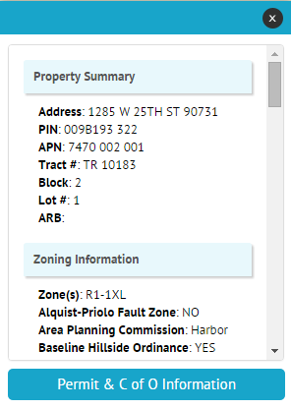

The Permit Information page displays and features a list of drop down menus: Permit Information, Building Information, Certificate of Occupancy, and Enforcement Case Records for the address that was selected.

